**PRESS RELEASE Friday 17 March 1pm 2017**

**THE ROYAL COURT THEATRE AND R.O.A.D ENTERTAINMENT RELEASE TRAILER AHEAD OF SCREENING OF NEW DOCUMENTARY FILMED IN TOTTENHAM, N17.**

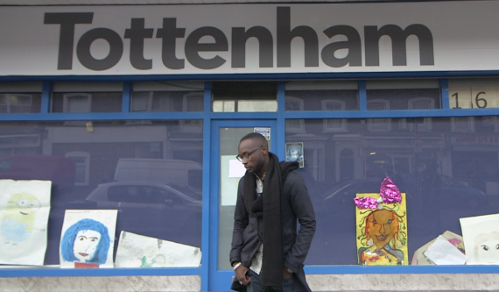

The Royal Court Theatre and R.O.A.D. Entertainment announce the screening details of ***Tottenham x Teriy***, a documentary film that takes a candid glimpse at those living in Tottenham, N17.

***Tottenham x Teriy*** looks beyond the youthful appetite for success to balancing social consciousness in the face of challenges like Brexit. To view the trailer see here <https://www.youtube.com/watch?v=vbvruqwykbY>

The short documentary spotlights 25 year old multi-award winning Music Executive and Entrepreneur Teriy Keys, Esq. as he retraces his journey from a childhood in care to running a fledging Entertainment company and Educational Training Centre in Tottenham, via a possible career in football with FC Barcelona, and teaming up with Dizzee Rascal as founding member of his independent label.

***Tottenham x Teriy*** is a story of ambition, innovation and perseverance placed within a community that has had its share of legacy issues. The running theme centres on the principles of remaining always determined.

Commissioned and supported by the Royal Court Theatre as part of the theatre’s three-year residency in Tottenham, N17, the documentary film is the convergence of theatre, music and art; with a core value of community interest at the heart.

Commenting on the project Moussa A Sylla, Tottenham Community Organiser said;

*"After the riots and way before, the youth in Tottenham have, for the majority of time, been labelled as bad and associated with foolishness and anti-social behaviour, especially those from black and ethnic minority backgrounds. Listening to the story of Tottenham boy Teriy Keys is so refreshing and up lifting and a great inspiration for others. Giving young people a place for their voices to be heard and giving them support to the things that matter to them can be the start of a journey towards a new life"*

The Royal Court Theatre will be launching the film on 8pm Thursday 30March 2017 with a screening at The Site, Royal Court Theatre, Sloane Square. Tickets can be booked here. <http://royalcourttheatre.com/book?eID=89967>

The screening will be followed by a panel discussion, details of those taking part to be announced.

**ENDS:-**

**For more information or images please contact;**

(Through the Royal Court Theatre**)** Anoushka Warden on 0207 565 5063 / [AnoushkaWarden@royalcourttheatre.com](mailto:AnoushkaWarden@royalcourttheatre.com)

(Through R.O.A.D. Entertainment) Patricia Odje [press@roadent.co.uk](mailto:press@roadent.co.uk)

**Tweet:** [@TeriyKeys](http://twitter.com/teriykeys) [@RoyalCourt](http://twitter.com/royalcourt) | **Hashtag:** #TxT

**NOTES TO EDITIORS:**

Previously signed to Dizzee Rascal’s Dirtee Stank imprint, **Teriy Keys, Esq.** is a multi-award winning Entertainment Executive, Producer and Founder of the R.O.A.D. Group of Companies.  In 2013, and again in 2016; Teriy Keys was short-listed in Music Week magazine's publication for the "30 under 30" best of the rest most influential music industry executives.

Awards / Accolades:

* Music Week – ‘30 under 30’ – [2013] (Best of the Rest)
* Award - Queen's Diamond Jubilee Award [2014]
* Association of Independent Music – Start Up's Award [2014]
* Award - Haringey Outstanding Contribution Award [2014 /15]
* Award - Haberdashers Award for Entrepreneurship [2015]
* Grammy Award [2016] – Grammy Foundation Award for R.O.A.D. Academy & Training Centre
* Music Week – ‘30 under 30’ - [2016] (Best of the Rest)
* Speaker – House of Parliament for The Great Debate Tour 2016 Finale
* Elected Member of Brit Awards Voting Academy

R.O.A.D. Entertainment under exclusive license from R.O.A.D. Visual Arts