PRESS RELEASE
Monday 11 September 2017

ROYAL COURT THEATRE ANNOUNCES TRANSFER OF THREE-TIME AWARD-WINNING EDINBURGH FESTIVAL FRINGE SHOW THE FALL

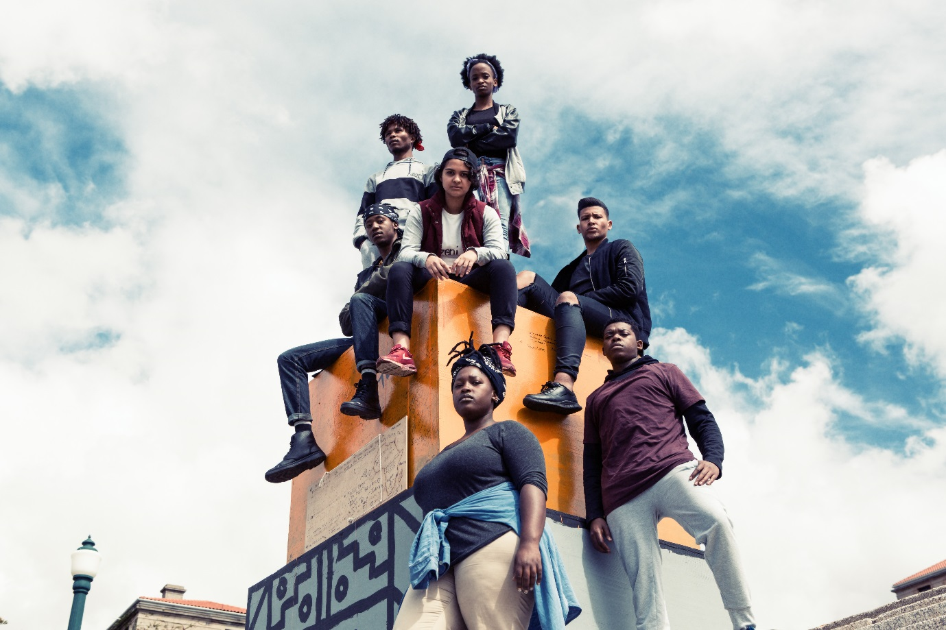
The cast of The Fall.

Following a critically acclaimed run at this year’s Edinburgh Festival Fringe the Royal Court Theatre presents the Baxter Theatre Centre at the University of Cape Town’s production of The Fall in the Jerwood Theatre Upstairs for a limited three week run, Tuesday 26 September 2017 – Saturday 14 October 2017. Press night is Thursday 28 September 2017, 7.15pm.

The Fall is written by Ameera Conrad, Oarabile Ditsele, Kgomotso Khunoane, Tankiso Mamabolo, Thando Mangcu, Sizwesandile Mnisi, Sihle Mnqwazana and Cleo Raatus, and has won The Scotsman Fringe First Award, The Stage Edinburgh Cast Award at this year’s Edinburgh Festival Fringe and the Fleur Du Cap Special Encore Award.

The production was a response by seven drama students and activists of the movements at the time. It does not offer solutions – it merely documents their experiences.

“That day we taught ourselves as the movement what we as the movement meant when we spoke about white supremacy, institutional racism and black pain at UCT.”

As the statue of colonialist Cecil Rhodes came down at the University of Cape Town, seven students wrote The Fall. It took South Africa and Edinburgh by storm and comes to the Royal Court for an exclusive limited London run.
As colonialist and patriarchal icons are dismantled across the world, The Fall goes to the heart of how race, class, gender, power and history's voices intersect.

“The atmosphere among my fellow comrades is euphoric. We have brought this change.”

In the wake of global events The Fall reminds us that decolonisation is still a relevant, vital and urgent topic all over the world.

Cast Curated by Ameera Conrad and Thando Mangcu. Facilitator Clare Stopford.
With Set Design by Patrick Curtis and Costume Design by Marisa Steenkamp.

The cast includes Ameera Conrad, Oarabile Ditsele, Zandile Madliwa, Tankiso Mamabolo, Sizwesandile Mnisi, Sihle Mnqwazana and Cleo Raatus

Commenting on The Fall Elyse Dodgson, International Director at the Royal Court Theatre said;

“The Fall is a story from the front line that resonates with any of us who have ever taken part in student revolt around the world and down the ages. We are very proud to bring The Fall to London as another link in the connection between the Royal Court and contemporary South African drama that began with Athol Fugard in the 1970s and was most recently celebrated in our co-productions of I See You by Mongiwekhaya in 2016. The rigour of its thinking and the energy of the extraordinary ensemble make The Fall an important story to see.”

In association with Assembly/Riverside.

Full listings details below.

-ENDS-
For more information or images please contact Anoushka Hay on 0207 565 5063 / AnoushkaHay@royalcourttheatre.com
Notes to Editors:
Press Night: Thursday 28 September 2017, 7.15pm.
Images: https://www.dropbox.com/sh/hfbjqu7oqd5776u/AACKmmcuYPMf96Zh9bslhhHUa?dl=0

Listing Information:

The Royal Court Theatre presents the Baxter Theatre Centre at the University of Cape Town
The Fall
Written by Ameera Conrad, Oarabile Ditsele, Kgomotso Khunoane, Tankiso Mamabolo, Thando Mangcu, Sizwesandile Mnisi, Sihle Mnqwazana and Cleo Raatus
Cast Curators: Ameera Conrad, Thando Mangcu
Facilitator: Clare Stopford
Jerwood Theatre Upstairs, Royal Court Theatre, Sloane Square, SW1W 8AS
Tuesday 26 September 2017 – Saturday 14 October 2017, 7.45pm
Press Nights 7.15pm Thursday 28 September 2017.
Age Guidance 14+
Standard Tickets £25 (Mondays all seats £12 available from 9am online on the day of performance).
Concessions previews £20

