PRESS RELEASE
Friday 5 October 2018

ROYAL COURT THEATRE ANNOUNCES CAST FOR THE CANE, WRITTEN BY MARK RAVENHILL AND DIRECTED BY ROYAL COURT ARTISTIC DIRECTOR VICKY FEATHERSTONE RUNNING IN THE JERWOOD THEATRE DOWNSTAIRS THURSDAY 6 DECEMBER 2018 – SATURDAY 26 JANUARY 2018.

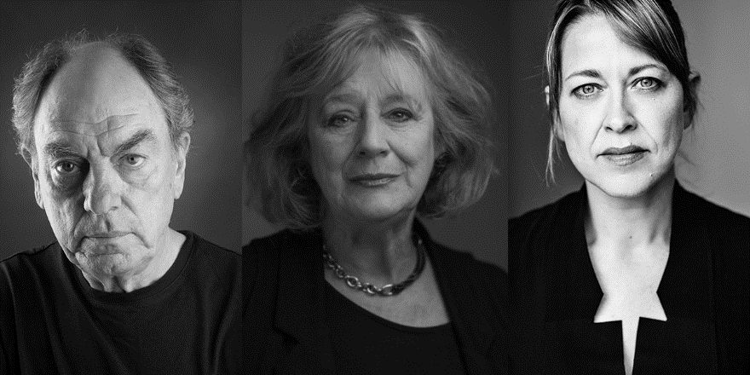
Cast in alphabetical order: Alun Armstrong, Maggie Steed and Nicola Walker

Alun Armstrong, Maggie Steed and Nicola Walker have been cast in the world premiere of The Cane, written by Mark Ravenhill and directed by Royal Court Artistic Director Vicky Featherstone.

With design by Chloe Lamford, lighting design by Natasha Chivers and sound design by David McSeveney.
The Cane will be performed in the Jerwood Theatre Downstairs Thursday 6 December 2018 – Saturday 26 January 2019. Press performances are 7pm Wednesday 12 December 2018 and 7.30pm Thursday 13 December 2018 with reviews embargoed until 11.59pm Thursday 13 December 2018.

"It will be the biggest send off any teacher has ever had. No teacher is as loved"

After 45 years as a dedicated teacher, Edward is looking forward to the imminent celebration to mark his retirement.

But his home is under siege. A mob of angry students have gathered. A brick has been thrown through the window, he and his wife haven’t left the house for six days, and now his estranged daughter has arrived with her own questions.

"Why would they attack the most popular teacher in the school?"

There will be a post-show talk with Artistic Director Vicky Featherstone and writer Mark Ravenhill on Tuesday 18 December 2018.

Full listings and biography information below.

Ends:-

For more information or images please contact Anoushka Warden on 0207 565 5063 / AnoushkaWarden@royalcourttheatre.com

Notes to Editors:

Press performances

The Cane | Jerwood Theatre Downstairs | 7pm Wednesday 12 December 2018 and 7.30pm Thursday 13 December 2018. Review embargo lifted 11.59pm Thursday 13 December 2018.

Biographies:

Mark Ravenhill (Writer)
For Royal Court: Shopping & Fucking (& Out of Joint), Product (& Paines Plough), Shoot/Get Treasure/Repeat (& Out of Joint/Paines Plough), Over There (& Schaubuehne Berlin).
Other theatre includes: Mother Clap's Mollyhouse, Citizenship (National); Pool No Water (Frantic Assembly/Lyric, Hammersmith); Life of Galileo, Candide (RSC).

Vicky Featherstone (Director)
For the Royal Court: Gundog, My Mum’s a Twat, Bad Roads, Victory Condition, X, Cyprus Avenue (& Abbey, Dublin/MAC, Belfast/Public, NYC), How to Hold Your Breath, God Bless the Child, Maidan: Voices from the Uprising, The Mistress Contract, The Ritual Slaughter of Gorge Mastromas; Untitled Matriarch Play, The President Has Come to See You (Open Court Weekly Rep).
Other theatre includes: What if Women Ruled the World? (Manchester International Festival); Our Ladies of Perpetual Succour (& National/West End/International tour), Enquirer [co-director], An Appointment with the Wicker Man, 27, The Wheel, Somersaults, Wall of Death: A Way of Life [co-director], The Miracle Man, Empty, Long Gone Lonesome (National Theatre of Scotland); Cockroach (National Theatre of Scotland/Traverse); 365 (National Theatre of Scotland/Edinburgh International Festival); Mary Stuart (National Theatre of Scotland/Citizens/Royal Lyceum, Edinburgh); The Wolves in the Walls [co-director] (National Theatre of Scotland/Tramway/Lyric, Hammersmith/UK tour/New Victory, NYC); The Small Things, Pyrenees, On Blindness, The Drowned World, Tiny Dynamite, Crazy Gary’s Mobile Disco, Splendour, Riddance, The Cosmonaut’s Last Message to the Woman He Once Loved in the Former Soviet Union, Crave (Paines Plough).
Television Includes: Where the Heart Is, Silent Witness.
Vicky was Artistic Director of Paines Plough 1997-2005 and the inaugural Artistic Director of the National Theatre of Scotland 2005-2012. Vicky is the Artistic Director of the Royal Court.

CAST BIOGRAPHIES

Alun Armstrong (Cast)
For the Royal Court: Cromwell, Mother’s Day, The Changing Room.
Other theatre includes: Exit the King (Theatre Royal, Bath); The Royal Hunt of the Sun, Death of a Salesman, Sweeney Todd, The Father, The Passion (National); The Front Page, Endgame, Insignificance (Donmar); The Baker’s Wife (West End); The Jew of Malta, Fashion, Les Misérables (& West End), Troilus & Cressida, The Winter’s Tale, The Crucible, The Taming of the Shrew, The Tempest, Nicholas Nickleby (& Broadway), Bastard Angel, The Loud Boys Life, Much Ado About Nothing (RSC).
Television includes: Frontier, Prime Suspect 1973, Dark Angel, Broken Biscuits, The Country Woman, Golden Years, Downton Abbey Christmas Special, Penny Dreadful, The Hollow Crown, Edwin Drood, This is Personal, New Tricks, Garrow’s Law, A Passionate Woman, Little Dorrit, The Dinner Party, Filth: The Mary Whitehouse Story, Kid of Chernobyl, Bleak House, When I’m Sixty-Four, Between the Sheets, Carrie’s War, The Inquisition, Sparkhouse, Bedtime, Messiah II, Waiters, The Cappuccino Years, Score, David Copperfield, Oliver Twist, This is Person, Aristocrats, In the Red, Underworld, Brazen Hussies, Tales from the Crypt, Breaking the Code, Les Misérables, Witness Against Hitler, Sorry About Last Night, Our Friends in the North, Doggin’ Around, MacGyver, Goggle Eyes, The Life & Times of Henry Pratt, Married with Children, Goodbye Cruel World, Stanley & the Women, Murder in Eden, Sticky Wickets, A Night on the Tyne, This is David Lander, No: 27, Bulman, Sharing Time, Nicholas Nickleby, Get Lost, Only Make Believe, Shooting the Chandelier, Days of Hope, The Stars Look Down, All Day on the Sands, Our Day Out, Measure for Measure, Sharp Intake of Breath, Z Cars, Enemy at the Door, Play for Today, Centre Play, Romance, Porridge, The Squirrels, The Sweeney, Public Eye, Father Brown, Justice, General Hospital, Villains, Advent of Steam.
Film includes: Possum, Funny Cow, Out of Innocence, Golden Years, Eragon, Oliver Twist, Millions, Van Helsing, Paradise Found, It’s All About Love, The Mummy Returns, Proof of Life, Harrison’s Flowers, Strictly Sinatra, Sleepy Hollow, Greenwich Mean Time, With or Without You, Onegin, The Saint, Braveheart, An Awfully Big Adventure, Black Beauty, Blue Ice, Patriot Games, Split Second, London Kills Me, The Widow Maker, American Friends, The Child Eater, White Hunter Black Heart, That Summer of White Roses, Billy the Kid & the Green, Baize Vampire, Krull, The French Lieutenant’s Woman, The Duellists, The Likely Lads, Existence, A Bridge Too Far, Get Carter.
Awards include: Olivier Award for Best Actor in a Musical (Sweeney Todd).

Maggie Steed (Cast)
For the Royal Court: Women Beware Women.
Other theatre includes: Pinter One (West End); Richard III (West End); The Birthday Party (Royal Exchange, Manchester); Trelawney of the Wells (Donmar); The School for Scandal (Theatre Royal, Bath); Kinderstransport (UK tour); Listen We’re Family (JW3); Uncle Vanya (Chichester Festival); The Belle’s Stratagem (Southwark Playhouse); The Constant Wife (Salisbury Playhouse); Hay Fever (West Yorkshire Playhouse); The History Boys (National & world tour); The Importance of Being Earnest (Oxford Playhouse); The Storm (Almeida); The War Plays, Much Ado About Nothing (RSC).
Television includes: Chewing Gum, Lark Rise to Candleford, Jam & Jerusalem, Victoria Wood: As Seen on TV, Born & Bred, Pie in the Sky, Martin Chuzzlewit, EastEnders.
Film includes: Fisherman’s Friends, Transformers: The Last Night, Paddington 2, Florence Foster Jenkins, Cloud Nine, The Imaginarium of Doctor Parnassus, The Painted Veil, Lipstick on Your Collar.

Nicola Walker (Cast)
For the Royal Court: Relocated, Fresh Kills, Sweetheart, The Libertine/The Man of Mode, Hated Nightfall.
Other theatre includes: A View from the Bridge (Young Vic/West End/Broadway); The Curious Incident of the Dog in the Night-Time, Season’s Greetings, Gethsemane, Tales from the Vienna Woods, Edmond (National); Di & Viv & Rose, The Dead Eye Boy (Hampstead); Mrs Klein, Cloud Nine (Almeida); Modern Dance for Beginners (Soho); Sexual Perversity in Chicago (Crucible, Sheffield); Passion Play (& Comedy), A Lie of the Mind (Donmar); Fifty Revolutions (Whitehall).
Television includes: Unforgotten, The Split, Collateral, River, Last Tango in Halifax, Babylon, Scott & Bailey, Prisoner’s Wives, Heading Out, Inside Men, Spooks, Being Human, Law & Order, Luther, Turn of the Screw, Oliver Twist, Torn, Broken News, People Like Us, The Last Train, Touching Evil, Chalk, A Dance to the Music of Time, Milner, Faith, Moll Flanders.
Film includes: Shooting Dogs, Shiner, Four Weddings & A Funeral.
Awards include: Olivier Award for Best Supporting Actress (Curious Incident of the Dog in the Night-Time).

Listings Information:

The Cane
Written by Mark Ravenhill
Directed by Vicky Featherstone
Jerwood Theatre Downstairs, Royal Court Theatre, Sloane Square, SW1W 8AS
Thursday 6 December 2018 – Saturday 26 January 2019
Monday – Saturday 7.30pm
Thursday & Saturday matinees 2.30pm
Captioned Performances Tuesday 8 January 7.30pm & Friday 18 January 7.30pm 2018
Audio Described Matinee Saturday 19 January 2.30pm 2018(Tour Tour 1pm)
Relaxed Performance Monday 14 January 7.30pm 2018
Press Performances 7pm Wednesday 12 December 2018 and 7.30pm Thursday 13 December 2018
Standard Tickets £12 - £49 (Mondays all seats £12 available from 9am online on the day of performance)
First Look Tickets** £12, £16, £25, £35
Concessions* £5 off top two prices (available in advance for previews and all matinees)
Under 26s £15 (available in advance for previews and all matinees)
Access £15 (plus a companion at the same rate)
*ID required. All discounts subject to availability.

