PRESS RELEASE Monday 31st October 2022

THE ROYAL COURT THEATRE ANNOUNCES New Plays: Japan 新作: 日本

THURSDAY 26 JANUARY - SATURDAY 28 JANUARY

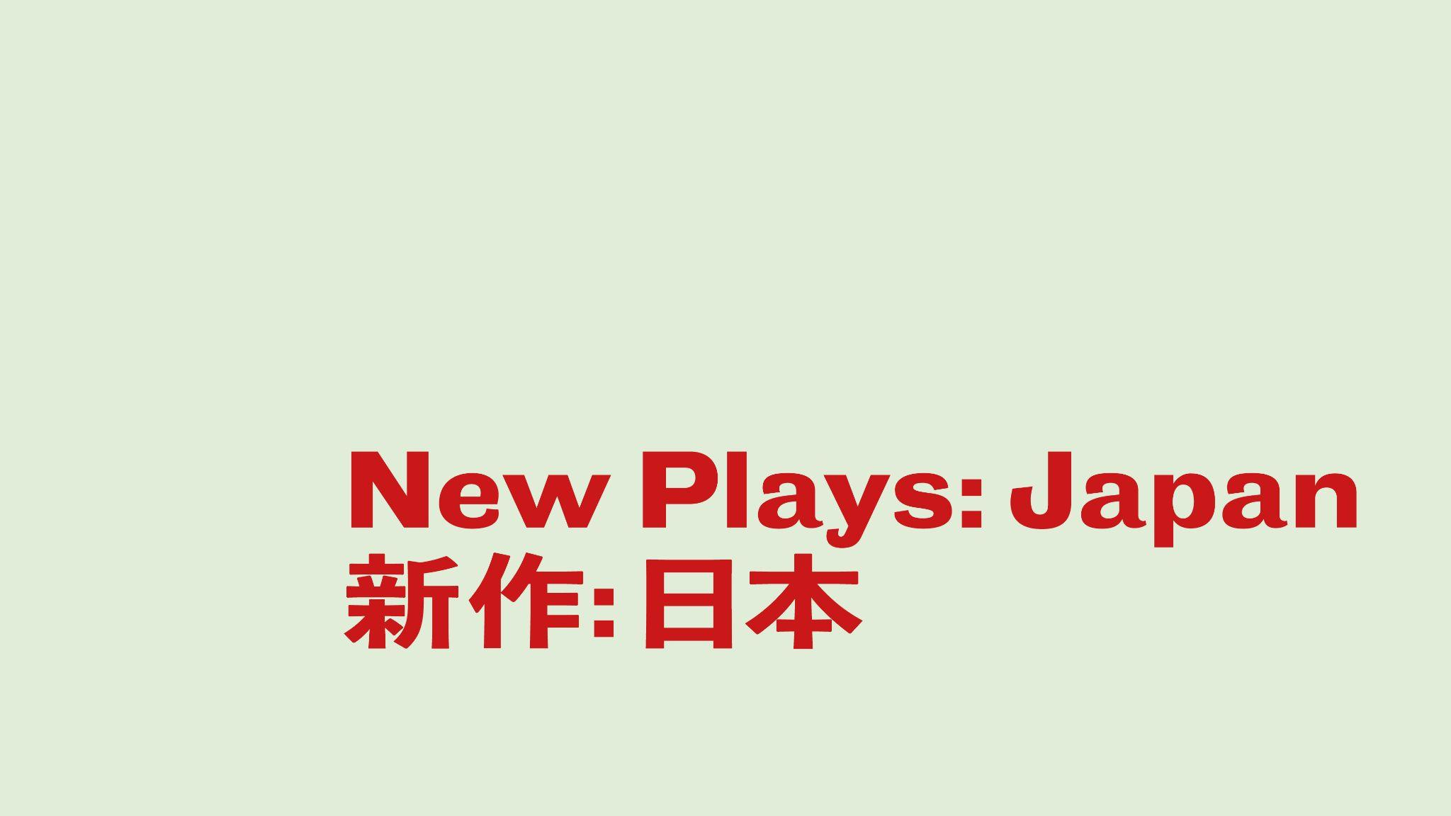

Today it has been announced that the Royal Court Theatre will present New Plays: Japan 新作: 日本from Thursday 26th - Saturday 28th January 2023. These staged readings bring brand new plays from three of the most exciting new voices in Japanese theatre to the Royal Court.

Adventurous in form, politically challenging and distinct in their worlds, these plays will be staged in translation as script-in-hand performances.

This series presents a selection of the work developed in a group for Japanese playwrights run by the New National Theatre Tokyo with the Royal Court and facilitated by writers and artists from both theatres.

The week of performances will include a panel discussion with all three writers and artistic director of NNTT Eriko Ogawa on Friday 27th January and an omnibus of all three plays on Saturday 28th January. Tickets are on sale now.

The series will include Not Yet Midnight (真夜中とよぶにはまだはやい) by Tomoko Kotaka, Onigorou Valley (その先、鬼五郎渓谷につき、) by Saori Chiba and 28 hours 01 minute (28時01分) by Shoko Matsumura.

Ali McDowall, playwright said ‘It was an enormous privilege to be able to work with this group of writers- I learned things during the time I spent with them that I'll use in my own work forever and will always cherish the time I spent with them. Their plays were- without exception- vibrant, searching, and endlessly innovative and I'm honoured to have played a small part in bringing some of Japan's new writing to the Royal Court.’

Eriko Ogawa, Artistic Director, New National Theatre Toyko, said ‘I am beyond excited that we are presenting New Plays: Japan as the culmination of the writers group the Royal Court Theatre and the New National Theatre, Tokyo have worked on together. Despite the challenges faced during the pandemic, 14 playwrights coming together to create and discuss new plays for a year and a half had great significance for them, writers of their generation, and for Japanese theatre as a whole. In addition to these Japanese productions, three plays will be staged in London. I cannot express how thankful I am for the team at the Royal Court for their continuous support towards the writers.’

Not Yet Midnight (真夜中とよぶにはまだはやい)
by Tomoko Kotaka
translated by Sayuri Suzuki

A night time power cut opens up moments of pause across one city. Three office workers are interrupted with their hands in the till. In a playground, a young couple begins to unravel. And a shop clerk tries and fails to move her last customer on.

Onigorou Valley (その先、鬼五郎渓谷につき、)
by Saori Chiba
translated by Susan Momoko Hingley

When two decontamination workers take a drive up into the hills above Fukushima, they enter an uneasy world governed by legend and forces beyond the human. A supernatural folk horror set in the deep woods of Onigorou Valley, seven years after the Fukushima nuclear disaster.

28 hours 01 minute (28時01分)
by Shoko Matsumura
translated by Sayuri Suzuki

Aoji is expecting her first baby. She wakes in the night. Her neighbour Uso calls round with an orange. And so begins a strange sequence of events that will test and shape her idea of what it is to be a mother.

New Plays: Japan 新作: 日本 is a co-production with the New National Theatre Tokyo, supported by The British Council.

ENDS-

Press contacts:

Amy Deering on Amy@breadandbutterpr.uk
Maisie Lawrence on Maisie@breadandbutterpr.uk
Ella Gold on EllaGold@royalcourttheatre.com

Biographies:

Writers:

Saori Chiba (千葉沙織)
Saori Chiba is playwright born in Tomioka, Fukushima in 1984. After studying at EN Drama Studio, she started her career as an actor. She began writing after the Great East Japan earthquake in 2011. The Royal Court Theatre × New National Theatre, Tokyo workshop is her first project as a playwright.

Tomoko Kotaka (小高知子)
Tomoko Kotaka is a playwright from Osaka. She started writing at Itami So-ryu Shijyuku in 2014. In 2016, Sayonara Akarui Biteikotsu (さよならあかるい尾骶骨) became the finalist for the 2016 Chikamatsu Award and in 2019, Hikari no naka de Me wo korasu (光の中で目をこらす) became the 2018 Japan Playwrights Association’s New Playwright’s Award finalist.

Shoko Matsumura (松村翔子)
Shoko Matsumura is a playwright, director, and actor. She began her acting career in 2000 in Tokyo. In 2013, she started her theatre company Momeraths as its playwright and director. She has done research based on her own experience and interests, and has produced numerous plays many of which focus on socially disadvantaged young people, problems arising in female lives, and the darkness in modern life. (Non-regular employment, poverty, sexual abuse, abortion, fertility treatment, childbirth, etc.) Her plays bring a beyond-real “new reality” on stage by their stories jumping beyond the audiences’ imagination and by utilizing poetic language and physical expression.

Translators:

Susan Momoko Hingley
Susan is a British-Japanese actress and writer, who translates Japanese and German plays into English. She has worked on literal translations of Brecht plays including the upcoming “The Good Person of Szechwan” (ETT), as well as “Threepenny Opera” (National Theatre), “The Resistible Rise of Arturo Ui” (Donmar) and “Puntila and His Man Matti” (Royal Lyceum).
As an actress, she has performed with the RSC, Shakespeare’s Globe, New National Theatre Tokyo and is associate artist of Tangled Feet. She is currently performing in the RSC’s “My Neighbour Totoro” at the Barbican. As a writer, she has written two full length plays “Petal” (Omnibus Theatre, 2022) and “Baaba’s Footsteps” (Vault Festival, 2020). She trained at East 15 Acting School and Ecole Philippe Gaulier in Paris after studying Law at the University of Warwick.

Sayuri Suzuki
Sayuri is a freelance interpreter and has worked in both theatre and film. Theatre productions include: “Les Miserables”, “Miss Saigon”, “Carousel”, “Romeo and Juliet”, “The Seagull”, “The Cherry Orchard”, “Twelfth Night”, “A Streetcar Named Desire” and “Bent”. Sayuri has translated English plays into Japanese: “Doubt”, “Welcome to the Moon”, “Danny and the Deep Blue Sea”, “Women of Manhattan”, by John Patrick Shanley, “The Floating Lightbulb”, “Second Hand Memories” by Woody Allen, “Wit” by Margaret Edson. Translation from Japanese into English also include: “The Good Doctor Yabuhara” by Hisashi Inoue for the Chijinkai production at the Edinburgh International Theatre Festival, “Hanare-Goze Orin” by Tsutomu Minakami for the Japan Festival in London.

Sayuri interprets every year for the Toyko International Film Festival and was awarded the Yuasa Yoshiko Translation Award for “The Floating Lightbulb” and “Arab Israel Cookbook” in 2007.

The New National Theatre, Tokyo (NNTT) is Japan's only national theatre dedicated to the performing arts of Opera, Ballet, Dance and Drama. Since it opened in 1997, the NNTT has presented world-class performances not only at it’s theatre in Tokyo but also at many regional theatres, and has come to occupy a familiar and much-loved place in the nation's cultural life.

The NNTT comprises the Opera Palace (1814 seats), Playhouse (1038 seats) and The Pit (open space theatre with flexible seating arrangements up to 468 seats), each of which uniquely contributes to an annual total of about 300 stage performances to the delight of approx. 200,000 theatregoers, including many visitors from overseas. The theatre is constantly active in staging productions, by itself or
in collaboration with other theatres throughout Japan and overseas.

Listings Information:

Double Bill
Thursday 26th January

7.00pm - Onigorou Valley (その先、鬼五郎渓谷につき、) and 28 hours 01 minute (28時01分)

Friday 27th January

7.00pm - Not Yet Midnight (真夜中とよぶにはまだはやい) and Panel Discussion with all three writers and the NNTT Artistic Director Eriko Ogawa

Saturday 28th January

4.00pm - Not Yet Midnight (真夜中とよぶにはまだはやい)

6.00pm - 28 hours 01 minute (28時01分)

8.00pm - Onigorou Valley (その先、鬼五郎渓谷につき、)

Pricing:

Standard tickets £8
Concessions £6

