Self-Care Guide: Sound of
the Underground by Travis Alabanza.
This document has been designed to support audiences attending performances of Sound of the Underground 19th January – 25th February 2023.
For some of us, we need more context of what we are about to see to feel safe, so we’ve created this document for those of us who would be comfortable with more information. We hope the information and resources in this document will help audiences experiencing the show, and support planning for anyone who may be concerned about their visit.

Contents
- About the show
- Content warnings
- Sensory Synopsis
- Helplines & support
- Self-care suggestions
- Thanks & about self-care

About the Show

“Ladies, Gentlemen, and then all the legends that have realised gender is a trap – introducing the Sound of the Underground.”
Out to the electric night, where the bassline jumps in the backstreet light. The true sound of the underground is tearing duct tape, frenzied costume fixes, lighting up cigarettes, jangling tips and a whole lot of chaos. This is not your average night at the theatre.
Legends of the London queer club scene come above ground to take over the Royal Court Theatre. Part-play, part-raucous cabaret, part-workers’ manifesto, join eight underground drag icons as they spill the tea, free the nipple and fight the shadowy forces that threaten their livelihoods. Bring some change. Tip generously.
Travis Alabanza’s first play for the Royal Court spotlights London’s iconic underground club culture and questions what it means to get your money’s worth when it comes to art.
Written by Travis Alabanza, co-created and directed by Debbie Hannan.

Age recommendation: 16+.

Content warnings

This show contains:
- Haze
- Strobe
- Flashing lights
- Sudden changes in lighting
- Sudden and loud noise
- Strong language
- Nudity
- Sexual imagery
- Description of a homophobic and transphobic incident
- Interaction with audience / direct address to audience
- Discussion of pay disparity and financial hardship
WARNING: The following section of this document contains information which may give away aspects of the plot.

Sensory Synopsis
KEY:
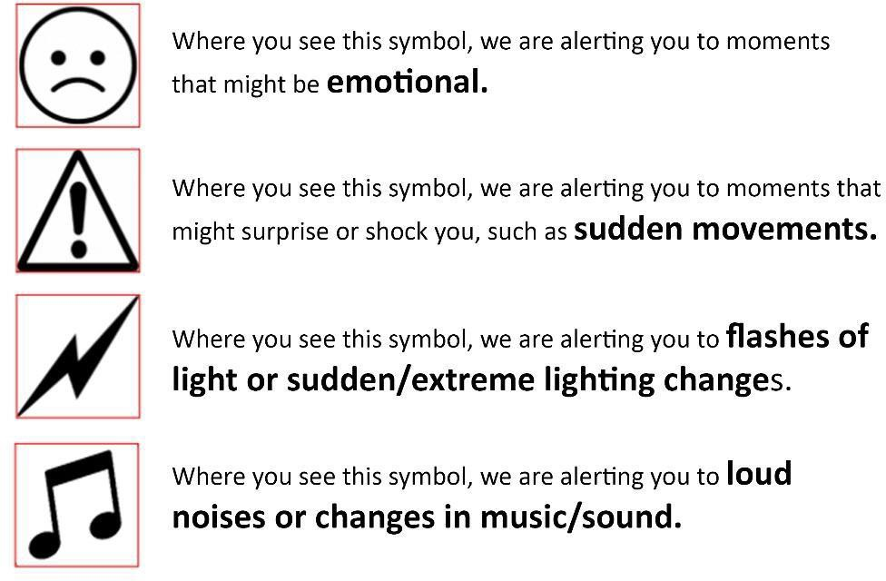

PROLOGUE:
THE TAKEOVER

We hear the voice of Miss Sharon le Grand. They cannot be seen.

Coloured spotlights move and shine into the audience and on the stage.

Performers make their way on stage. They appear from all around the auditorium including the Circle level and the doors to the Stalls that the audience have come in. They speak to the audience. Some performers get close to audience members. The audience is encouraged to cheer.

The performers stand on stage and introduce themselves.
Strong language is used.

Midgitte Bardot enters from the back of the auditorium shouting for someone to give them a lighter.

Midgitte Bardot lights a cigarette with a lighter.

The curtain onstage is raised.
We see a kitchen. In the back right corner there is a colourful dressing room. Behind a curtain we can see a Green Room and performers getting changed.

ACT ONE:
THE PLAY – TODAY IS THE DAY
Suspenseful music plays.

The lights on stage get brighter.

The mobile phone that Rhys’ Pieces puts on the table rings.

The performers argue in this scene.
They may raise their voices and shout at one another.

Lily SnatchDragon shouts down the phone.

Music plays as Wet Mess walks across the stage.
They do a quick dance move.

The lighting changes quickly in this scene.
Different performers are lit as they make speeches.

Sue Gives a F*ck describes a homophobic incident.

Music gets louder as Sue Gives a F*ck speaks.

In this scene the performers describe a plot to kill RuPaul.

There are sounds of battle

There are colourful flashing lights during the battle.

The performers change into camouflage outfits in view of the audience.
We see performers in a state of undress.

Midgitte rides around the stage on a miniature tank.

The performers come into the audience to collect money.
You do not have to pay them unless you want to.

The colourful flashing lights come back on and music loudly plays.

Money falls from the ceiling.

ACT TWO:
THE BUSINESS

The ceiling of the room on stage lifts out of view.

The performers and Stage Managers clean the stage and remove the set.

The performers lip sync to audio.

The audio is edited clips of the performers speaking about their experience of the drag industry. They speak passionately and sometimes shout and use swear words.

Sharon le Grand sings Sound of the Underground

There is a blackout.

INTERVAL

The lights in the auditorium will get brighter.

The interval will last around 20 minutes. Music plays in the auditorium. There will be announcements throughout the building telling you when there are 5 minutes left.

ACT THREE:
THE DREAM/ THEIR ARRIVAL

The curtain is raised to signal the start of the scene.

The performers do their individual acts introduced by Sue Gives a F*ck.

Strong language is used in this scene.

There is mention of racism, homophobia, transphobia, sex work,

In between each act there is a blackout.

There is strobe lighting used throughout this scene.

Each act includes music.

There is nudity in this scene.

Midgitte sprays fake urine on the audience while at the top of a cherry picker.

Chiyo is upset and raises their voice.

The performers sing Sound of the Underground.

CURTAIN CALL.
THE END.

Helplines & support

There are references in the show to the ongoing cost of living crisis and the effect that capitalism has on the queer community.
If you’re affected by the show’s themes and need support, or just want someone to chat to, you can call LGBT Foundation on 0345 3303 03030.
If you don’t need immediate support but would like to learn more about services that may be available for yourself or someone you know, we’d recommend looking into the organisations MindOut, Stonewall and LGBT Foundation.

LGBT Foundation
https://lgbt.foundation
MindOut
https://mindout.org.uk
Stonewall
https://www.stonewall.org.uk

Self-care suggestions

If you’re concerned about attending the show, there are a few things we’d suggest that might help.
Before the show
Read the content warnings before deciding to see the show.
Come with a friend
It might be worth seeing if you can book to see the show with a friend, family member or someone you trust.
After the performance
If you’ve found the show distressing, we’d suggest talk to someone you’re with, calling a friend, or contacting one of the support services listed on the previous page.

Thanks & about self-care

In writing this document, we were inspired by recent approaches taken by several other companies. We are grateful to everyone whose work has informed our own approach, but especially the Self-Care Guide created for Nouveau Riche’s production of For Black Boys Who Have Considered Suicide When the Hue Gets Too Heavy by Ryan Calais Cameron at New Diorama Theatre and Clean Break’s production of Typical Girls by Morgan Lloyd Malcolm at Sheffield Theatres. As that document explains:
‘The concept of self-care comes from the Black Feminist movement. Self-care is a choice to listen to our needs and look after ourselves, so we are able to keep going and live our best lives, despite the difficulties we experience in life and how they make us feel.’
Finally, our thanks to you for reading this, and for coming to the show – if you choose to.

