Self-Care Guide
& Content Warnings.

Hope has
a Happy Meal

by

Tom Fowler.

Royal Court Theatre.

Self-Care Guide:
Hope has a Happy Meal.
This document has been designed to support audiences attending performances of Hope has a Happy Meal
3 June—8 July. 2023.

For some of us, we need more context of what we are about to see to feel safe, so we’ve created this document for those of us who would be comfortable with more information.
We hope the information and resources in this document will help audiences experiencing the show, and support planning for anyone who may be concerned about their visit.

Contents
- About the show
- Content warnings
- Sensory synopsis
- Helplines & support
- Self-care suggestions
- Thanks & about self-care

About the show
“Hope? Hope, is that you?”

Years and years ago, Hope disappeared. Now, she’s back. To find something she left behind.

But in the People’s Republic of Koka Kola – a world of dwindling resources, corruption and corporate giants – what happens to Hope?

Follow Hope on a surreal and frenetic quest through a hyper-capitalist country in this new play by Tom Fowler, directed by Royal Court Associate Director, Lucy Morrison.

Age recommendation: 14+.

This This show contains strobe, haze, flashing lights, very loud and sudden noise, including gun shots,
strong language and staged violence that some may find distressing. Please see Content Warnings and Self-Care support and suggestions below for more information.

Content warnings
- Strong language
- Clowns (coulrophobia)
- The popping of balloons (globophobia)
- Stylised depiction of torture (waterboarding)
- Stylised depiction of an attempted suicide (hanging)
- Depiction of kidnapping/hostage taking
- Descriptions and depictions of police brutality
- Descriptions and depictions of violence against women and trans women
- Descriptions and depictions of murder
- Use of fake blood
- Graphic depictions of violence including:
  - Strangulation
  - Stabbing
  - Shooting

WARNING: The following section of this document contains information which may give away aspects of the plot.

Sensory Synopsis

KEY:
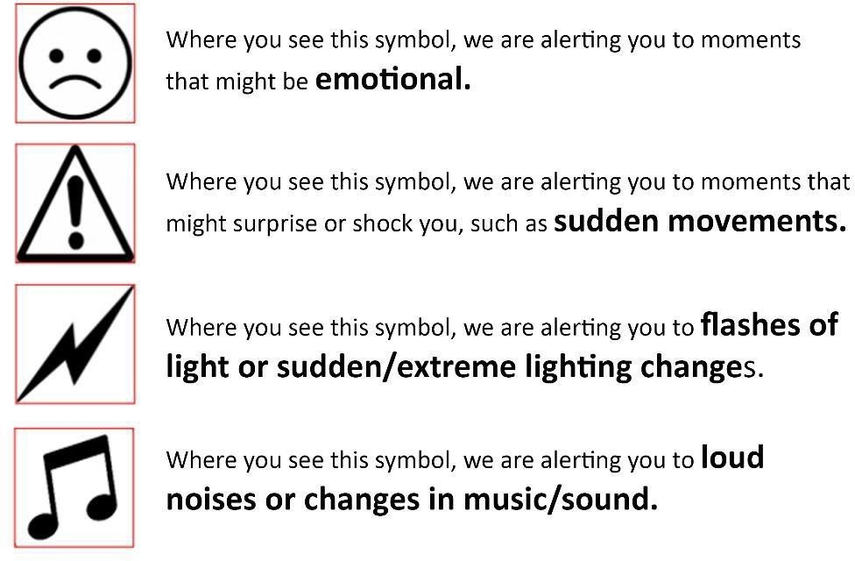

SCENE ONE:

As you enter the auditorium you hear a soundscape which includes chimes, airplane engines and birds chirping.

There are bars of multi-coloured light that slowly pulse and change colour.

The lights turn white.

We hear an airline announcement.

There is a lit exit sign at the top of the stage. This is not an emergency exit. In the unlikely event of an emergency, please follow the instructions of staff.

We hear a power surge.

The lights flicker and turn off.
This is a signal that the play is about to begin.

The lights turn on. There are two actors on stage.

There is mention of having a panic attack in this scene.

There is swearing in this scene including the use of an extreme swear word.

There is mention of invasion and war in this scene.

There is mention of cancer in this scene.

There is mention of craving nicotine in this scene.

There is mention of death by falling angel in this scene.

The exit sign light turns on.

The CAPTAIN comes into the auditorium from a side door near the audience and speaks into a microphone.

HOPE has a panic attack.

HOPE vomits water in this scene.

Disco music plays. It starts quieter and then gets louder.

Orange lights turn on.
They slowly pulse on and off in time with the music.

SCENE TWO:

Music plays quietly in the background.

There is mention of alcohol and depictions of drinking in this scene.

There is swearing in this scene.

The music gets louder.

There is smoking in this scene.

The main lights turn off.
Bars of purple coloured light flash.

The lights come back on.

WAITRESS and HOPE dance.

WAITRESS and HOPE shout to be heard above the music.
The main lights turn off.
Bars of purple coloured light flash.
The lights come back on.

HOPE and WAITRESS smoke cigarettes.

We hear the bass from the music playing quietly.

The main lights turn off.
Bars of purple coloured light flash.

The lights come back on.

We hear road noise.

There is mention of drugs in this scene.

The lights change quickly.

NEIGHBOUR is annoyed at WAITRESS.

The baby makes cooing sounds.

The lights change.
They pulse ominously.

The baby cries.

We hear a pulsing sound.
HOPE shouts.

We hear a gameshow theme tune.

The lights turn red.

An actor dressed as a CLOWN appears on stage.

There is a sustained beeping sound when the clown introduces themself.

There are recordings of audience chanting and shouting played during this scene.

CLOWN shouts at HOPE during this scene.

There is mention of being hated in this scene.

We hear a buzzer.

CLOWN gets angry and pops three balloons with a pin.

Lights flash around the spinning wheel on stage.

There is mention of torture and depictions of waterboarding in this scene.

There is mention of child abandonment in this scene.

The lights get darker.

We see CLOWN put a cloth over HOPE’s face as though to begin waterboarding.

We hear a power surge.

The lights go off.

We hear HOPE struggling to breathe.

Blue lights come on quickly.

We hear banging on a door.

ISLA wakes HOPE up with a start.

OFFICER shouts from offstage.

ISLA and HOPE run away.

Rock music plays.

The lights get darker.
Orange lamps flash in time with the music.

SCENE THREE:

We briefly see HOPE and ISLA hiding in a train toilet.

We hear a chime.

CONDUCTOR enters from a side door near the audience and speaks into a microphone.

In this scene there is swearing and mention of:

Murder
Police brutality
Suicide
Abuse

HOPE unzips her trousers and uses the toilet.

We hear a chime.

CONDUCTOR enters from a side door near the audience and speaks into a microphone.

The lights turn off.

We hear the song ‘I Saw the Light’ by Hank Williams.

We hear a lorry horn honk.

Dim blue lights come on.

LORRY DRIVER sings along to the music.

LORRY driver wears an eye patch.

In this scene there is mention of:
Alcoholics Anonymous (AA)

Alcohol addiction

Vomiting

We hear the song ‘I Saw the Light’ by Hank Williams.

The lights turn off

The lights come back on.

We hear a car speeding past.
The lights turn off.

The lights come back on.
They a blue in colour and flicker.

We hear an engine whirr.

The lights turn off.

The lights come back on.
Red and blue lights flash.

We hear a siren.

The lights change quickly.

RANGER shouts “Help!”.

We see RANGER with a noose around his neck.

ISLA and HOPE help the RANGER to remove the noose from his neck.

Ranger gets annoyed with ISLA for giving him rope burn.

The baby cries.

RANGER is upset.

There is mention of death in this scene.

The lights turn off.

Soothing music plays.

The lights come back on slowly.

ALI lights a match.

There is a small fire in a bucket on the stage.

There are depictions of alcohol and drinking in this scene.

There is mention of murder, and urination in this scene.

There is smoking in this scene.

ISLA says that ALI is cute.

OFFICER enters pointing a gun at ISLA.

ISLA is afraid.

ISLA and OFFICER argue. They raise their voices.

OFFICER holds the gun to ISLA’s head.

The baby cries.

OFFICER threatens to kill ISLA.

OFFICER moves to leave and ISLA shouts at him to “Wait!”.

ISLA says goodbye to the baby.

ALI enters holding a knife.

ALI stabs OFFICER in the side.

OFFICER is in pain.

ISLA points the gun at OFFICER.

HOPE, ISLA and OFFICER all raise their voices.

ALI takes the gun.
He suggests tying OFFICER up.

We hear the song ‘I Saw the Light’ by Hank Williams.

The lights turn off.

The lights turn on.

We hear howling wind.

The lights turn off.

We hear static.

The lights turn on.

We hear rain.
There is a storm.

The lights turn off.

We hear static.

The lights turn on.

We hear birdsong.

WAYNE says he needs to go to the hospital.

LOR appears suddenly at the back of the stage.
She is holding a shotgun.

We hear the song ‘Strawberry Fields' by The Beatles.

The lights turn off.

The actors set up a table and chairs on the stage.

SCENE FOUR:

The lights turn on.

We hear ‘We’ll Meet Again’ by Vera Lynn playing on the radio.

There is swearing in this scene.

There is mention of death in this scene.

There are mentions of alcohol and depictions of drinking in this scene.

HOPE and LOR argue.

There is mention of child abandonment in this scene.

The lights turn off.

We hear pulsing tones.

The lights turn on.

There is reference to being sexual aroused in this scene.

WAYNE shouts that he needs to poop.

ALI has the gun with him.

HOPE is sad that LOR is upset with her.

The lights turn off.

We hear pulsing tones.

The lights turn on.

The lights turn off.

We hear pulsing tones.

The lights turn on.

The baby cries.

LOR and HOPE drink wine.

LOR tells HOPE that HOPE’s parents are both dead.

LOR and HOPE argue about HOPE’s son.

The lights turn off.

We hear pulsing tones.

The lights turn on.

LOR and HOPE laugh loudly.

There is mention and depictions of drunkenness.

There is reference to sex in this scene.

ISLA and ALI kiss.

The lights turn off.

We hear pulsing tones.

The lights turn on.

HOPE and LOR shout from offstage.

ISLA turns the radio on and we hear upbeat music.

LOR and HOPE are wearing tutus. They do a dance.

The music changes to a slow song.

We hear banging.

The music is turned off.

The banging continues.

HOPE turns the music back on.

The lights turn off.

We hear pulsing tones.

The lights turn on.

The above sequence happens three times as LOR and HOPE appear more drunk.

The lights turn on.

HOPE makes a buzzing sound with her lips.

LOR and HOPE argue about HOPE’s son.

There is mention of running away in this scene.

LOR screams and throws her cup.

We hear the baby cry and ISLA singing from the baby monitor.

We hear an ominous pulsing.
We hear gameshow theme music and the CLOWN’s voice through the baby monitor.

HOPE puts the baby monitor in a drawer and slams it shut.

The lights turn off.

We hear pulsing tones.

The lights turn on

HOPE is asleep at the table.
She wakes up with a start.

HOPE lights a cigarette.
WAYNE calls from the basement.

HOPE screams at WAYNE.
HOPE takes the gun from the drawer.

The lights turn off.

We hear pulsing tones.

The lights turn on.

WAYNE urinates.

HOPE ties WAYNE to a chair.

HOPE lights a cigarette and shares it with WAYNE.

HOPE leaves the lighter on the floor.

WAYNE says that he is lonely.

HOPE tells WAYNE about her son.

HOPE runs off stage.

We hear a high-pitched sustained toned.

The lights turn off.

We hear static and a chaotic beat.

SCENE FIVE:

The lights turn on.

We hear classical music.

We see the chair that WAYNE was in is now empty.

ROY and HOPE argue.

HOPE points the gun at ROY.

PANDORA screams and drops a plate.
There are mentions of drugs and alcohol in this scene.

The lights turn off.

We hear pulsing tones.

The lights turn on.

There is haze in this scene.

We hear birdsong.

HOPE speaks to her dead mother.
She apologises for leaving.

ANGEL comes on stage in an angel costume.

ANGEL talks about feeling overwhelmed and like life is too hard.

There is mention of redundancy, the climate crisis and cost of living in this scene.

GROOM calls from off stage.

ANGEL lights up his halo.

The lights turn off.

We hear pulsing tones.

The lights turn on.

WAYNE shouts from the basement.

The lights turn off.

We hear static and a chaotic beat.

The lights turn on.

WAYNE appears on stage covered in blood.

We hear the baby from the baby monitor.

WAYNE and ISLA fight.

ISLA screams.

WAYNE chokes ISLA.

HOPE shoots WAYNE.
We hear the gunshot and see a small flash.

ISLA runs offstage.

We hear gentle music and the sound of waves.

The lights turn off slowly.

We hear the voice over of a news report.

There is mention of murder and imprisonment in this scene.

The CEO comes into the auditorium from a side door near the audience and speaks into a microphone.

The lights come on.

We hear gulls and the sound of water.

We hear a whistle from off stage.
LOR and HOPE hug.

HOPE cries.

We hear a whistle from off stage.

HOPE says goodbye to LOR.

We hear a phone ringing.

We hear pulsing tones.

The lights turn off.

The lights turn on.
We hear quiet background music.

We hear a powering down.
The lights go out.

CURTAIN CALL
THE END

Helplines & support
If you’re affected by the show’s themes and need support, or just want someone to chat to, you can call Samaritans on 116 123 any time 24/7 for free.

If you prefer to text, the UK has a free 24/7 service: just text

SHOUT to 85258.

If you don’t need immediate support but would like to learn more about mental health and services that may be available for yourself or someone you know, we’d recommend looking into the organisation MIND: https://www.mind.org.uk/

Self-care suggestions
If you’re concerned about attending the show, there are a few things we’d suggest that might help.

Before the show
Read the content warnings before deciding to see the show.

Come with a friend
It might be worth seeing if you can book to see the show with a friend, family member or someone you trust.

During the performance
You’re welcome to leave the auditorium at any point.
The venue’s bar will remain open during and after the show. If you’ve found the show distressing, we’d suggest talk to someone you’re with, calling a friend, or contacting one
of the support services listed on the previous page.

Thanks & about self-care
In writing this document, we were inspired by recent approaches taken by several other companies. We are grateful to everyone whose work has informed our own approach, but especially the Self-Care Guide created for Nouveau Riche’s production of For Black Boys Who Have Considered Suicide When the Hue Gets Too Heavy by Ryan Calais Cameron at New Diorama Theatre and Clean Break’s production of Typical Girls by Morgan Lloyd Malcolm at Sheffield Theatres. As that document explains:

‘The concept of self-care comes from the Black Feminist movement. Self-care is a choice to listen to our needs and look after ourselves, so we are able to keep going and live our best lives, despite the difficulties we experience in life and how they make us feel.’

Finally, our thanks to you for reading this, and for coming to the show – if you choose to.

